**Directions for Extra Credit**

1. **Log in to the Clever App: (username is** [**s+ID#@gse.cusd80.com**](mailto:s+ID#@gse.cusd80.com)**).**

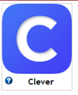

1. **Click on the McGraw Hill App. **
2. **On the Lighter BLUE tab, click on the current Chapter we are working on.** 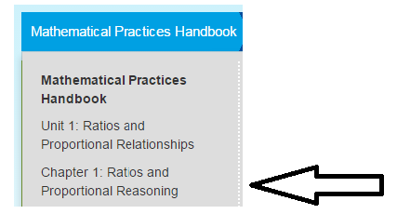
3. **On the Darker Blue tab to the right, scroll down to Chapter Review and click on it.** 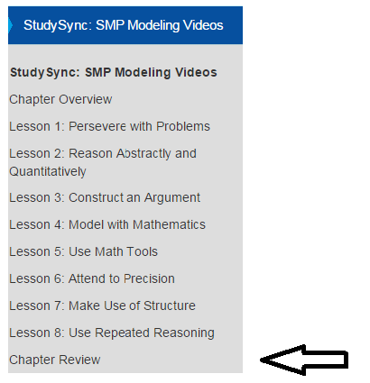
4. **To the right under Lesson Resources, click on the red check mark.** 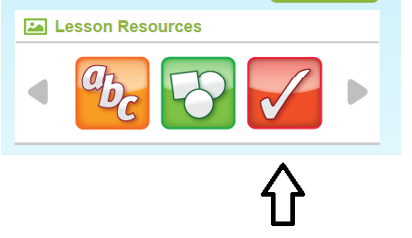
5. **Click on the first Chapter Test Review.** 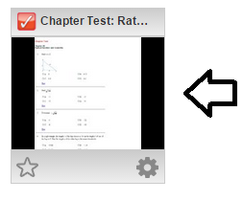
6. **Practice all the problems. If you need help click on the Hint button. At the end, check your answers. **
7. **When you have scored 70% or better, email me for your extra credit or print the page and bring to class. You can even snap a picture of it on your phone and show me in class. MAKE SURE I CAN SEE THE SCORE AND CHAPTER! Email: herz.jayme@cusd80.com**